# Angular Modules and Routing Exercises

## Create Registration Form

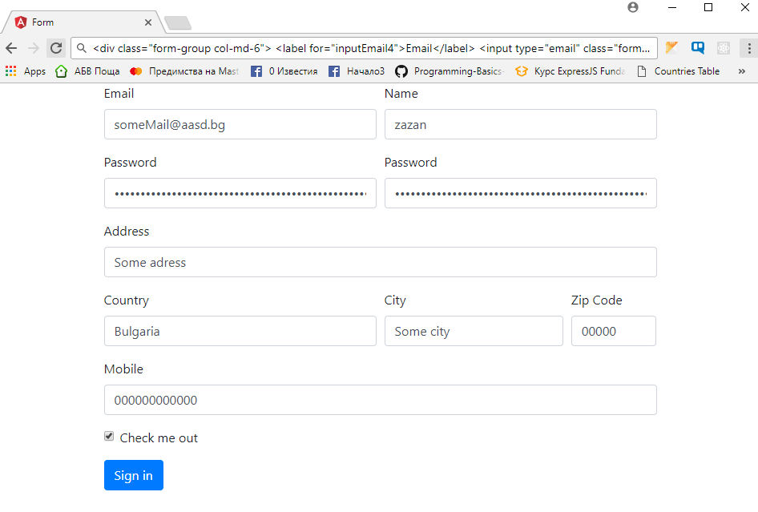

## Add Validations

### Validate All Fields

Add appropriate validation to all fields, while leaving the ' Mobile 'field and the ' Zip Code' to be optional

Create logic that checks if both passwords match.

1. **Add Pass Confirmation Validation**

Create logic that checks if both passwords match.

### Add Email Validation

Create logic that checks if the email is valid, using RegEx.

### Add Unique Email Check

Create a list of n mock email addresses in a service.

Connect the list to the email field, in such way, that whenever a user tries to register with occupied address display error.